**EFR32BG22 Bluetooth ESL Node Design Reference Manual**

Silicon Labs provides customers with a reference design for BLE ESL (electronic shelf label) node solutions in a 3.7” EPD size with EFR32BG22, EPD (electronic paper display), touch interface, LEDs, accelerometer, and NFC tag. This document describes this ESL node reference design including RF test data as well. Also, design files including schematic and layout CAD designs, BOM, PDF and Gerbers, are available under Silicon Labs website at [www.silabs.com](http://www.silabs.com).

**KEY POINTS**

* Brief description of EFR32BG22 QFN40 BLE ESL Node reference design
* RF test data provided, including antenna impedance, gain and efficiency, conducted and radiated fundamental and harmonics EIRP data, radiation patterns
* Design files are available for customers reference at [www.silabs.com](http://www.silabs.com)

The ESL design utilizes an EFR32BG22 chip in a QFN40 package.

The design is pre-compliance tested and appeared to be fully compliant with CE and FCC regulatory standards at the maximum output power level of +6 dBm on a 2-layer PCB.

The BLE ESL reference design includes the following circuit components:

* EFR32BG22C224F512GM40
* Built-in PCB BLE antenna
* Reset and user buttons
* 3.7” EPD with FPC connector
* Touch Interface with FPC connector
* 10-pin mini-simplicity debug connector
* External flash memory
* 2 x CR2450 coin cell batteries in parallel connection
* RGB LEDs with optional lightguide booster
* NFC Tag with PCB antenna (NT3H2111)
* Accelerometer for motion detection (BMA400)
* Number of PCB layers: 2
* PCB size: 102 x 52 mm

## Introduction

The EFR32BG22 QFN40-based BLE ESL node reference design is virtually provided for customers, since design files, including schematic and layout CAD design files, BOM, PDF and Gerbers, are available under [www.silabs.com](http://www.silabs.com) but there is no orderable part number for the board design itself.

The design is also pre-tested by Silicon Labs and is fully compliant with CE and FCC regulatory standards at the TX output power level of +6 dBm using a 2-layer PCB.

The module utilizes 2 electrical layers and an on-board printed antenna, and it runs from two CR2450 coin cell batteries. The entire module dimension fits the selected 3.7” EPD and is approximately 102 x 52 mm.

The module has the so-called 10-pin mini-simplicity header for programming and debugging purposes (see connection details in [AN958](https://www.silabs.com/documents/public/application-notes/an958-mcu-stk-wstk-guide.pdf) application note) a well.

The on-board printed antenna is tuned together with the EPD and when the coin cell batteries are being inserted into, no plastic enclosure is considered. So, for design implementations with plastics, Silicon Labs recommends checking the antenna impedance since some fine-tuning (probably BOM or antenna length change) might be required in its final environment.

The photo of the ESL reference design (top and bottom sides) is shown in Figure 1.1 below.

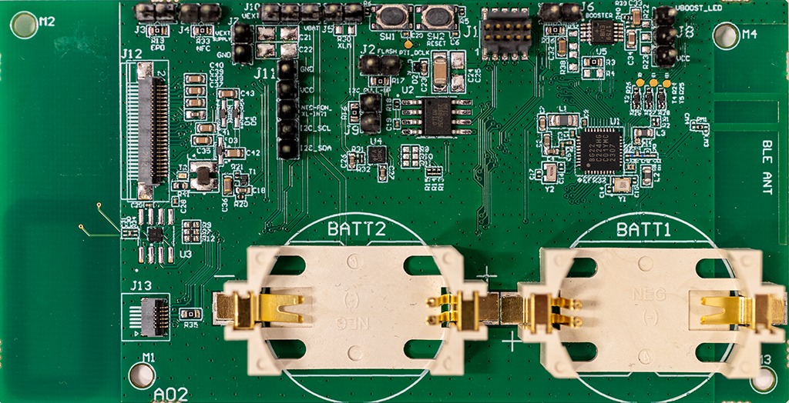

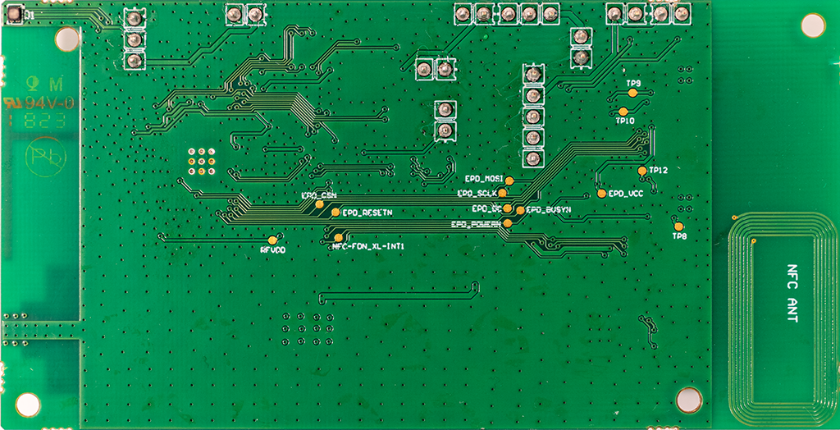

**Figure 1.1 EFR32BG22 BLE ESL Design**

## Schematic Design

The complete schematic design of the EFR32BG22-based ESL reference module can be found in the full design pack provided by Silicon Labs and is also available under [www.silabs.com](http://www.silabs.com). Since this reference manual focuses on the RF design part of the module, this section shows the RF focused schematic part of the entire design.

The EFR32BG22 RF part of the schematic is shown in the Figure 2.1 below.

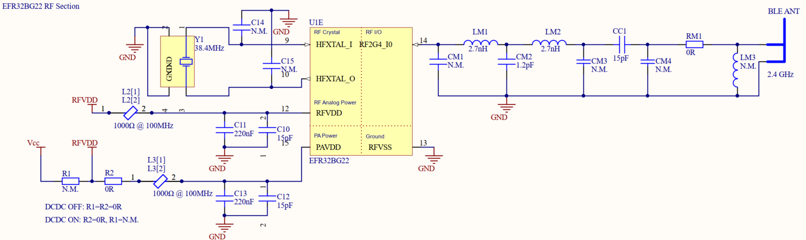

**Figure 2.1 RF part of the BLE ESL schematic design**

The design includes both low- and high-frequency crystals and the on-chip DCDC converter is also being utilized. Both RFVDD and PAVDD nets are connected to the internal DCDC converter’s output to minimize the current consumption and thus maximize the battery life. However, there is BOM-option to not utilize the DCDC converter and to connect each VDD pins to the battery voltage directly.

The RF front-end path can be divided into two separate parts: EFR32BG22 matching network including components CM1-2-3 and LM1-2; printed antenna and antenna matching network including components CM4, RM1 and LM3. CC1 is a DC-blocking and RF-bypassing capacitor in the series RF path. The printed antenna is a standard inverted-F antenna, similarly, as used on Silicon Labs reference 2.4 GHz radio board designs. The 50-ohm point in the RF-FE path is between the EFR32BG22 and antenna matching networks, i.e., at either side of the CC1 series component. So, conducted measurements can be performed by sniffing the RF-FE path at either side of the CC1 component.

The RF matching network elements are realized by SMD 0201-sized components, capacitors from Murata GRM0335C and inductors from Murata LQP03TN series.

The recommended maximum TX output power level is +6 dBm, but the module is also capable of transmitting up to +8 dBm however power levels above +6 dBm cannot be guaranteed over temperature and process variations.

## Interfaces and Configurations

BLE ESL node design includes several pin headers to provide options for detailed current consumption measurements, power on/off peripheral components (e.g., NFC, accelerometer, flash) and configure the design functionality. It also includes some configuration options to change the system functionality.

J1

Mini Simplicity

J2

Flash Power On/Off

J10

Power Supply Select

J4

NFC Power On/Off

J8

LED Supply Select

J6

LED Boost On/Off

J9

I2C Pull-ups On/Off

J5

Acc. Power On/Off

J7

VEXT Supply

J3

EPD Power On/Off

J11

I2C Interface

RESET_TOUCHn/LED_BST_EN Select

R36

R37

R38

R3

R4



DCDC On/Off

R1

R2

L1

J12

EPD

J13

Touch

**Figure 3.1 ESL Node Interfaces and Configurations**

**J1 Mini Simplicity Connector**

J1 Mini Simplicity connector provides SWD, AEM, PTI, VCOM and virtual UART ports for programing and debugging the target MCU. See details from [AN958](https://www.silabs.com/documents/public/application-notes/an958-mcu-stk-wstk-guide.pdf) application note.

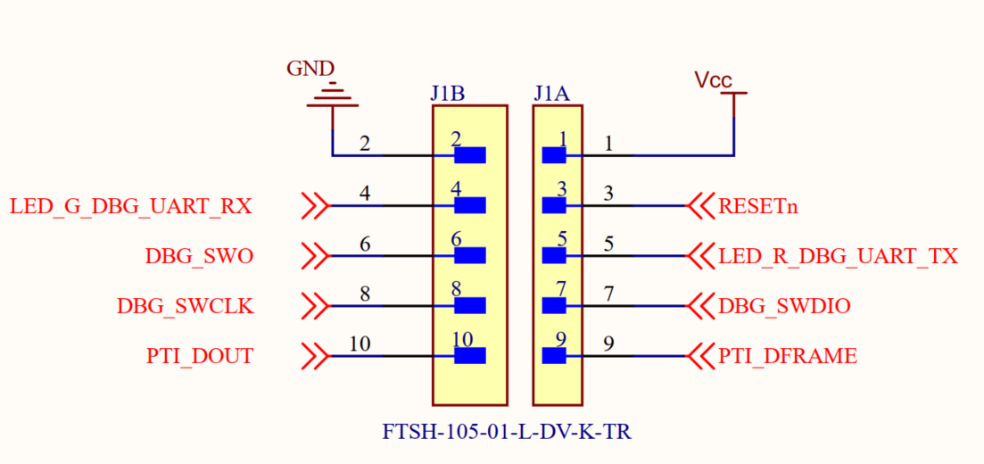

**Figure 3.2 Mini Simplicity Interface**

**J2 Flash Power On/Off**

Flash IC power supply can be permanently enabled/disabled by placing/removing jumper on header J2. Also Flash IC current consumption can be measured from this header by connecting current meter on series to J2.

Note: By default, 0ohm resistor (R17) is mounted to bypass the J2 header. Remove the resistor to enable Flash IC Power On/Off controlling in header J2.

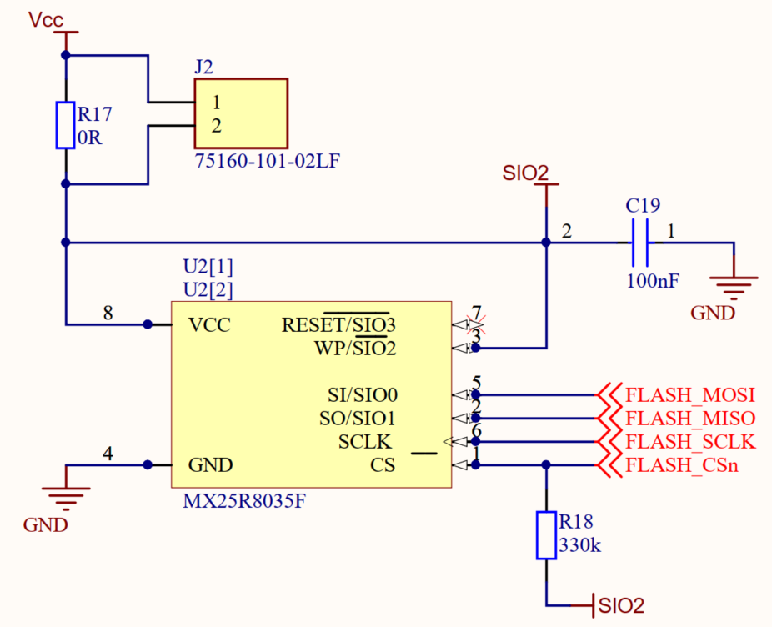

**Figure 3.3 J2 Flash Power On/Off**

**J3 EPD Power On/Off**

EPD power supply can be permanently enabled/disabled by placing/removing jumper on header J3. Also, EPD current consumption can be measured from this header by connecting current meter on series to J3.

Note: By default, 0ohm resistor (R19) is mounted to bypass the J3 header. Remove the resistor to enable EPD Power On/Off controlling in header J3.

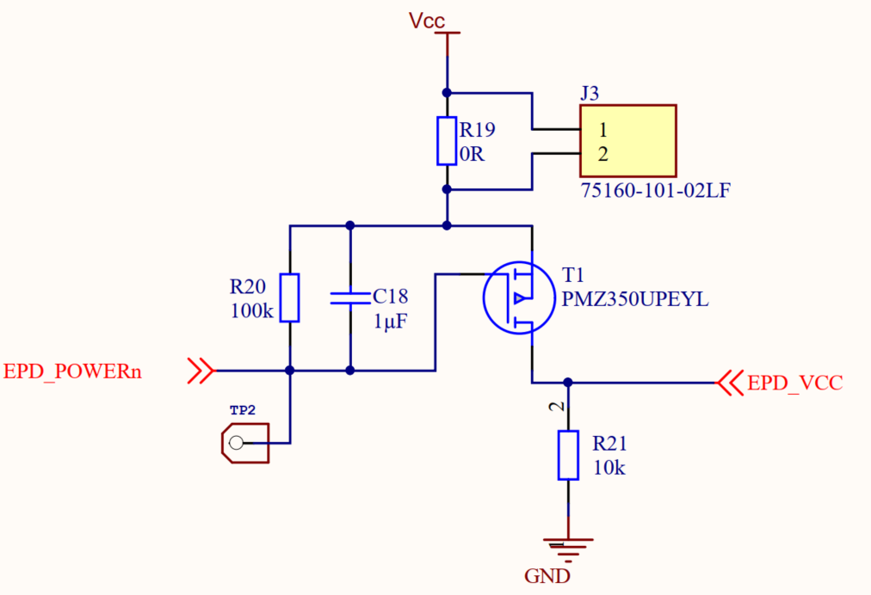

**Figure 3.4 J3 EPD Power On/Off**

**J4 NFC Power On/Off**

NFC IC power supply can be permanently enabled/disabled by placing/removing jumper on header J4. Also, NFC IC current consumption can be measured from this header by connecting current meter on series to J4.

Note: By default, 0ohm resistor (R33) is mounted to bypass the J4 header. Remove the resistor to enable NFC IC Power On/Off controlling in header J4. See also “J9 I2C Pull-ups Enable/Disable”.

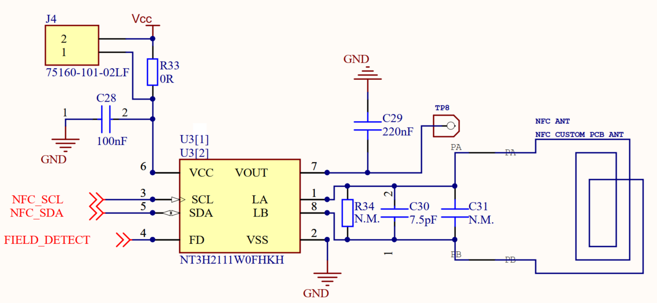

**Figure 3.5 J4 NFC Power On/Off**

**J5 Accelerometer Power On/Off**

Accelerometer IC power supply can be permanently enabled/disabled by placing/removing jumper on header J5. Also, accelerometer IC current consumption can be measured from this header by connecting current meter on series to J5.

Note: By default, 0ohm resistor (R30) is mounted to bypass the J5 header. Remove the resistor to enable accelerometer IC On/Off controlling in header J5. See also “J9 I2C Pull-ups On/Off”.

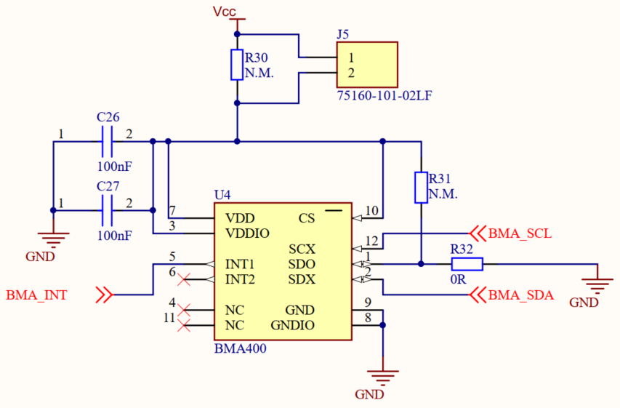

**Figure 3.6 J5 Accelerometer Power On/Off**

**J6 LED Boost On/Off**

LED can be optionally (see J8 LED Supply Select) powered from LEDs’ boost DC-DC converter. LED Boost IC can be permanently enabled/disabled by placing/removing jumper on header J6. Also, LEDs’ boost DC-DC converter current consumption can be measured from this header by connecting current meter on series to J6.

Note: By default, 0ohm resistor (R36) is mounted to bypass the J6 header. Remove the resistor to enable DC-DC converters on/off controlling in header J6.

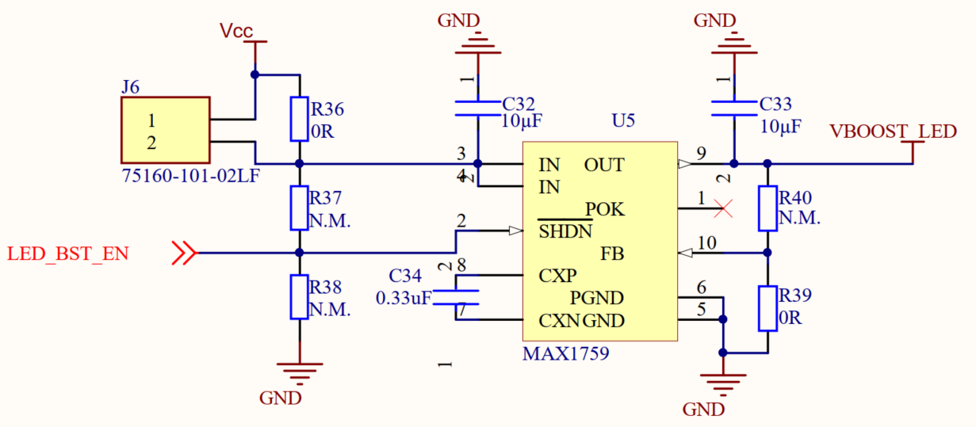

**Figure 3.7 J6 LED Boost On/Off**

**J7 VEXT Supply**

BLE ESL Node operating voltage (VCC) can be supplied either from externally (J7 VEXT Supply) or from 2 X CR2450 batteries (VBAT). Note: Actual VCC selection is done with a jumper from J10 VCC Select.

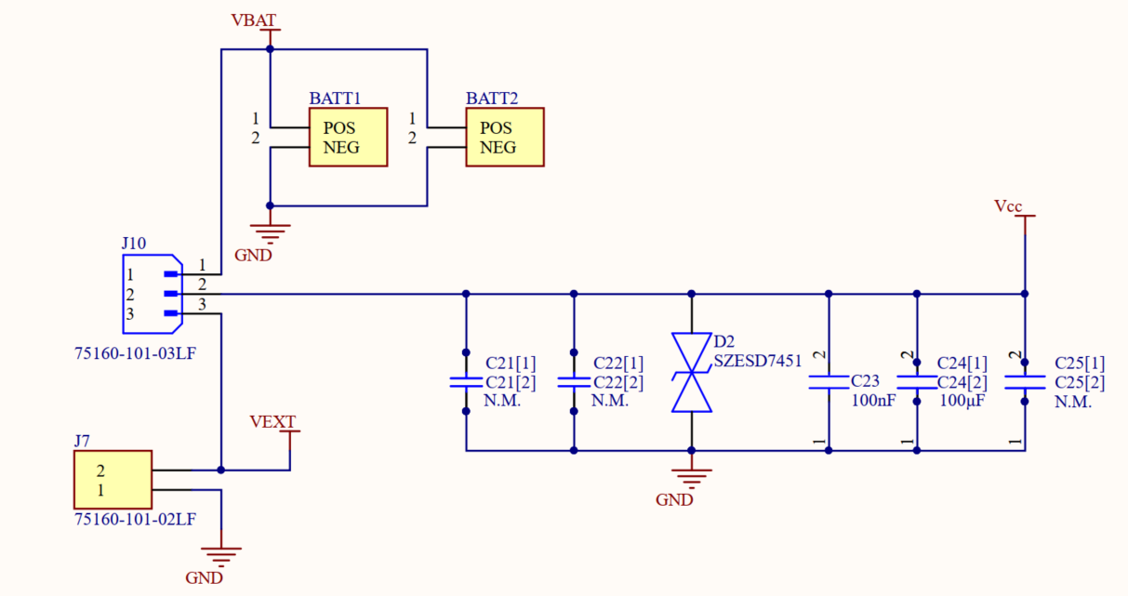

**Figure 3.8 J7 VEXT Supply**

**J8 LED Supply Select**

LED can be powered either from boost DC-DC converter (VBOOST_LED) (see. J6 LED Boost On/Off) or directly from VCC.

From J8 it can be selected which supply is used. Placing a jumper between J8 pins 1 and 2 will select VBOOST_LED as LEDs’ supply. Placing a jumper between J8 pins 3 and 2 will select VCC as LEDs supply.

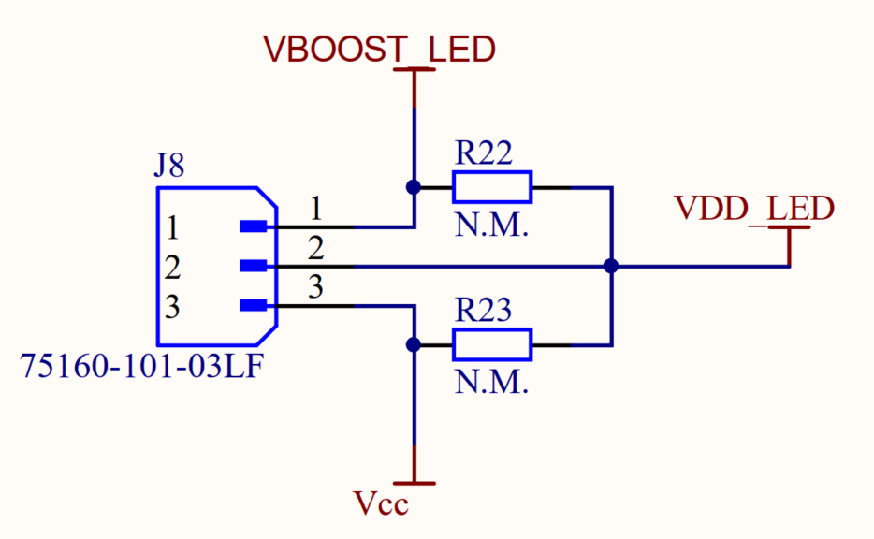

**Figure 3.9 J8 LED Supply Select**

**J9 I2C Pull-ups On/Off**

If no I2C peripherals (NFC, accelerometer) are powered, I2C pull-ups should be disabled to avoid unexpected current flow. I2C pull-ups can be permanently enabled/disabled by placing/removing jumper on header J9.

Note: By default, 0ohm resistor (R16) is mounted to bypass the J9 header. Remove the resistor to enable I2C pull-ups on/off controlling in header J9.

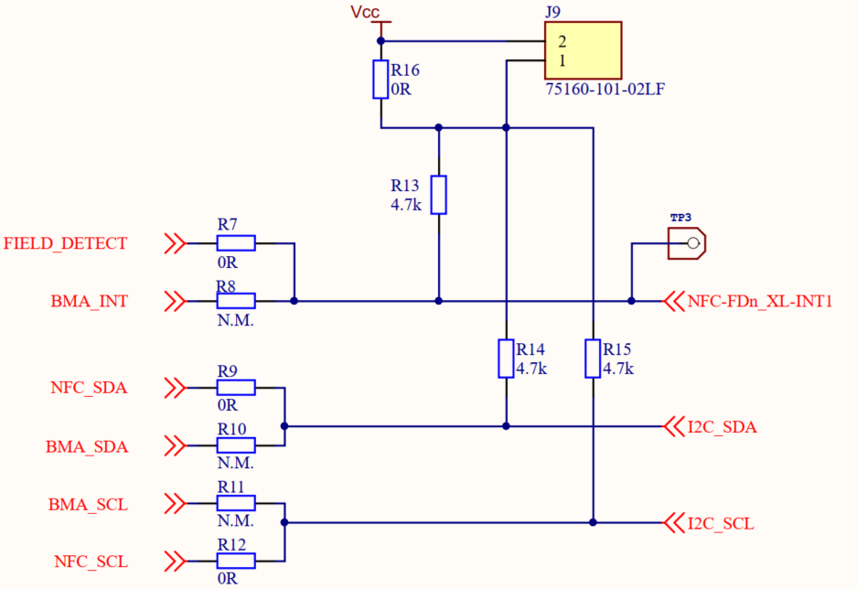

**Figure 3.10 J9 I2C Pull-ups On/Off**

**J10 VCC Select**

BLE ESL Node operating voltage (VCC) can be supplied either from 2 X CR2450 batteries (VBAT) or externally (J7 VEXT Supply). From J10 it can be selected which supply is used. Placing a jumper between J10 pins 1 and 2 will select VBAT as VCC. Placing a jumper between J10 pins 3 and 2 will select VEXT as VCC.



**Figure 3.11 J10 VCC Select**

**J11 I2C Interface**

Header J11 provides access to ESL Node I2C bus. This can be used to monitor I2C communication or to connect external I2C peripheral.

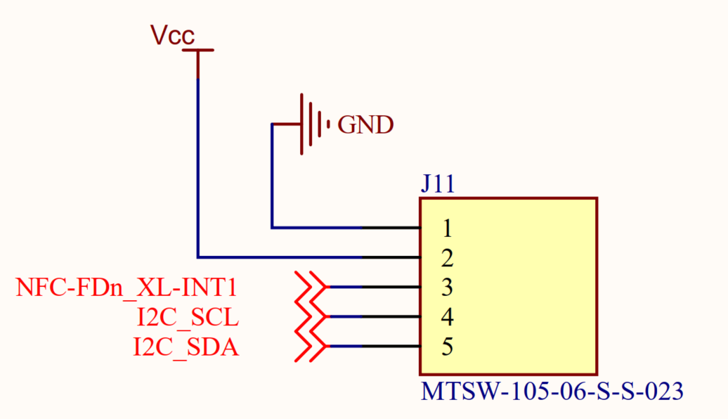

**Figure 3.12 J11 I2C Interface**

**J12 EPD Interface**

The Electronic Paper Display is connected to J12. ESL Node includes necessary electronics to support Pervasive Display EPDs. The design and schematics follow the Pervasive Display “EPD Driving Circuit” reference circuitry supporting displays sizes between 1.54” …4.37”. See details from Pervasive Display web site ([www.pervasivedisplays.com/](http://www.pervasivedisplays.com/)).

**J13 Touch Interface**

ESL Node supports Pervasive Display touch EPDs. The touch EPD touch flex is connected to J13. See details of touch EPDs from Pervasive Display web site ([www.pervasivedisplays.com/](http://www.pervasivedisplays.com/)).

**DC-DC On/Off**

EFR32BG22 includes internal DC-DC to generate DVDD, RFVDD and PAVDD. Using internal DC-DC converter provides the best power efficiency. If the DC-DC converter is not used, all voltages is supplied from external source.

If DC-DC converter is not used, L1 must be removed. By default, L1 is mounted (DC-DC enabled) and R1 is removed.

|  |  |
| --- | --- |
|  |  |

**Figure 3.13 DC-DC Enable/Disable**

**RESET_TOUCHn / LED_BST_EN Selection**

EFR32BG22 port PB00 has two different functions that can be configured by mounting/removing some resistors. By default, PB00 is configured to control LEDs’ boost DC-DC shutdown control (LED_BST_EN). In case of touch EPD is used, PB00 must be configured to work as touch IC reset (RESET_TOUCHn). If PB00 is used ad touch reset control, resistor R3 must be removed and R4 must be mounted. LEDs’ boost DC-DC shutdown can be still manually controlled by pulling LED_BST_EN either high (mount R37, DC-DC enabled) or low (mount R38, DC-DC shutdown).

|  |
| --- |
|  |
|  |

**Figure 3.14 RESET_TOUCHn / LED_BST_EN Selection**

## Layout Design

The complete layout design of the EFR32BG22-based ESL reference module, in CAD format as well, can be found in the full design pack provided by Silicon Labs and is also available under [www.silabs.com](http://www.silabs.com).

Snapshots from the layout design of EFR32BG22 BLE ESL module are shown in Figures 4.1 and 4.2 below.

The board design follows the generic RF layout recommendations as much as possible on this 2-layer, space-constrained design. The top layer basically consists of all components, including the coin cell batteries but excluding the RGB LED component which is mounted on the bottom layer where the EPD is also bent and facing. The bottom layer also ensures the low-impedance return path for the RF part of the design by having continuous and unbroken ground pour beneath the RF section. The 2.4 GHz BLE antenna is printed on the top layer, while the NFC low-frequency antenna is printed on the bottom layer. The BLE antenna appeared to provide good antenna efficiency and pattern properties. The antenna has a separate area on the PCB as well as shown in the figures below and its main radiator part is placed away from the coin cell battery to avoid any possible shielding effects of it.

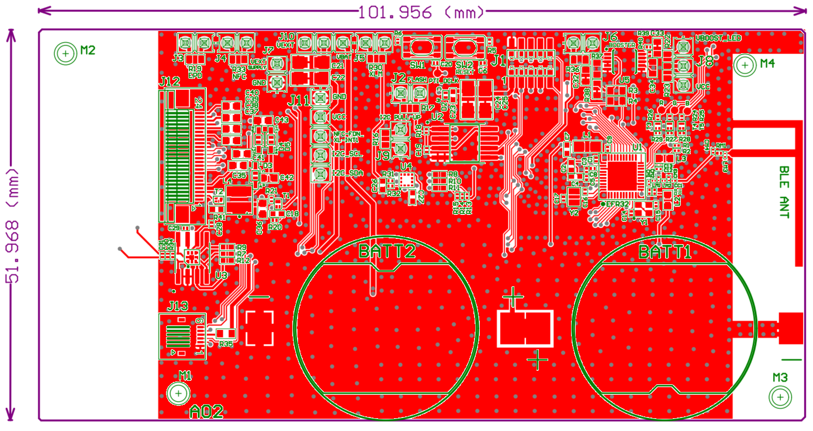

**Figure 4.1 BLE ESL node layout design: top layer**

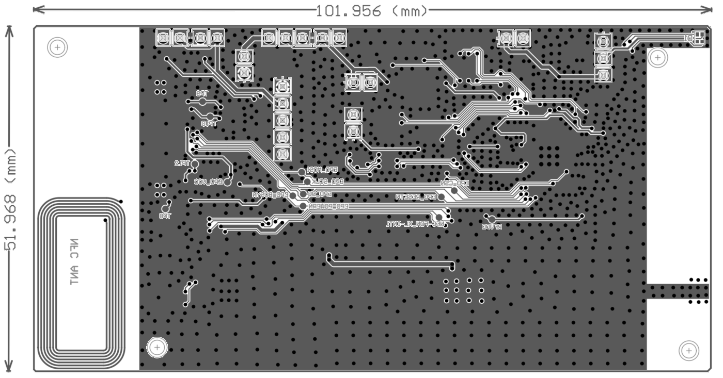

**Figure 4.2 BLE ESL node layout design: bottom layer**

In some cases, the minimum distance between the components is so small that the solder mask does not fit between the pads. This layout issue was only recognized after prototyping, so the layout was not changed/fixed to reflect the test results and design files on the manufactured PCB.

## Antenna Simulations

The 2.4 GHz BLE antenna design has been simulated in a 3D EM simulator, in CST. The simulated antenna structure and PCB is shown in Figure 5.1 below. It is a simplified structure, including the EPD partly overlapping the BLE antenna beneath the PCB and with the coin cell battery placed closer to the antenna.

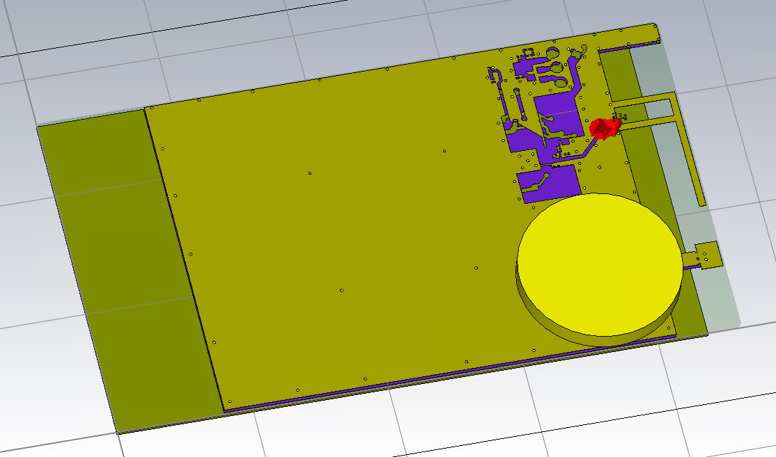

**Figure 5.1 EFR32BG22 BLE ESL Design – Simplified simulated structure in CST**

The simulated antenna parameters are plotted in the following figures below.

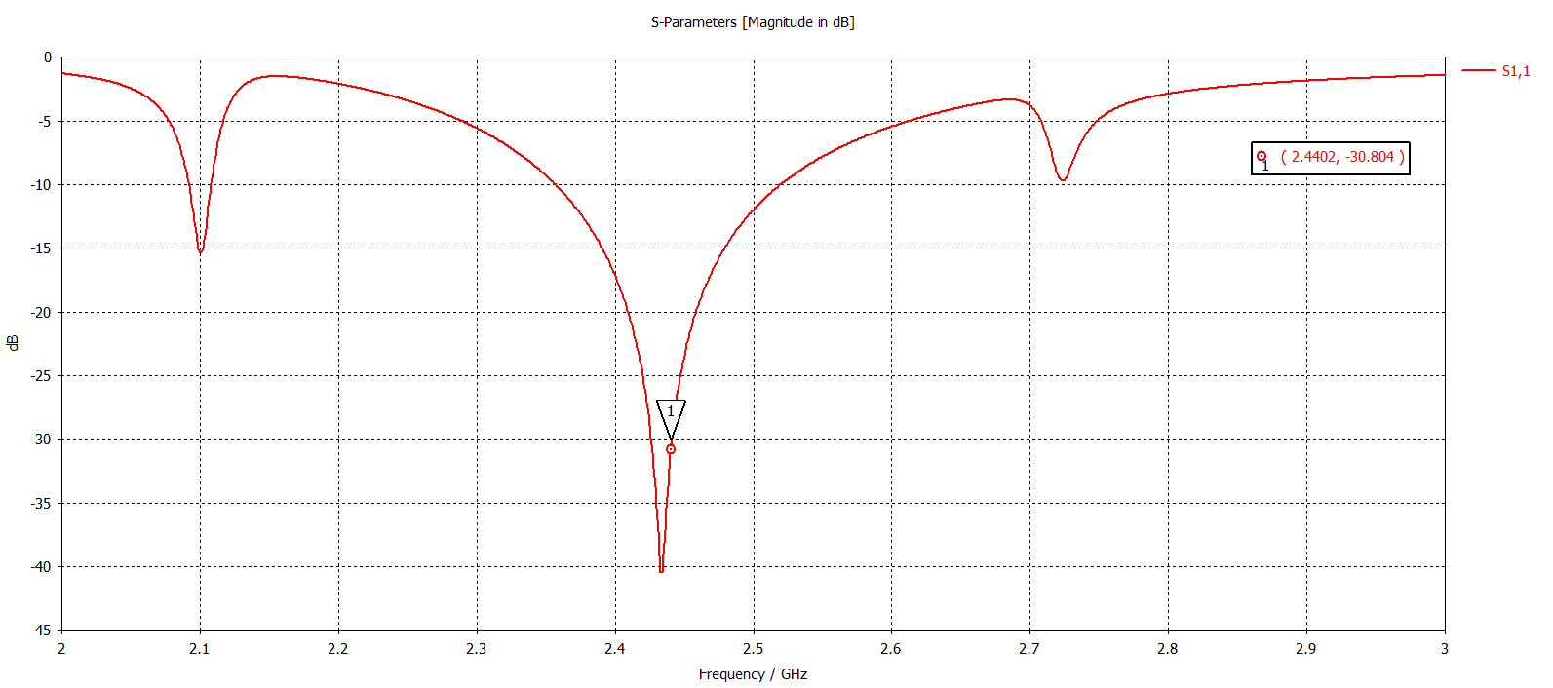

**Figure 5.2 Simulated antenna S11**

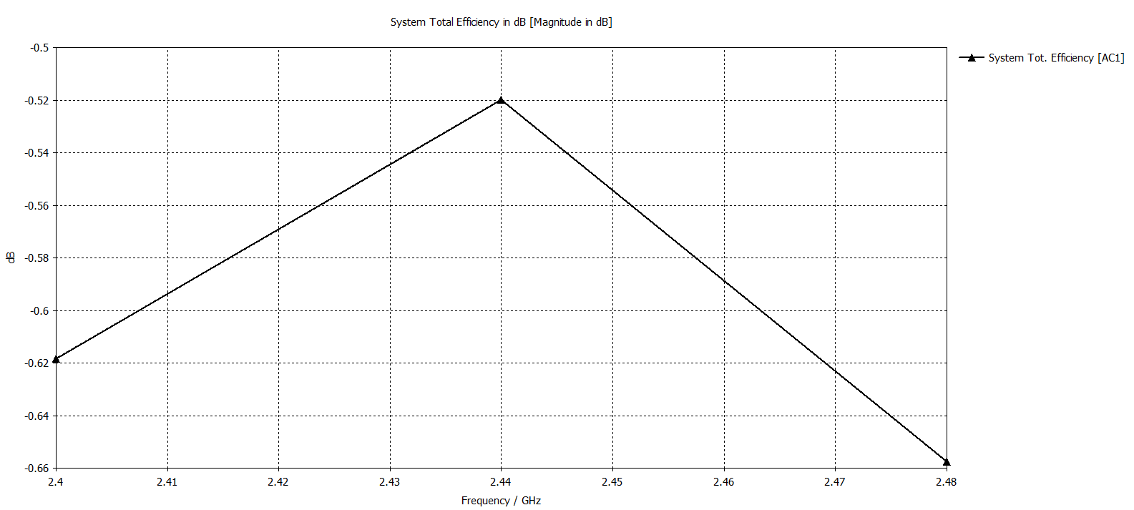

**Figure 5.3 Simulated antenna efficiency**

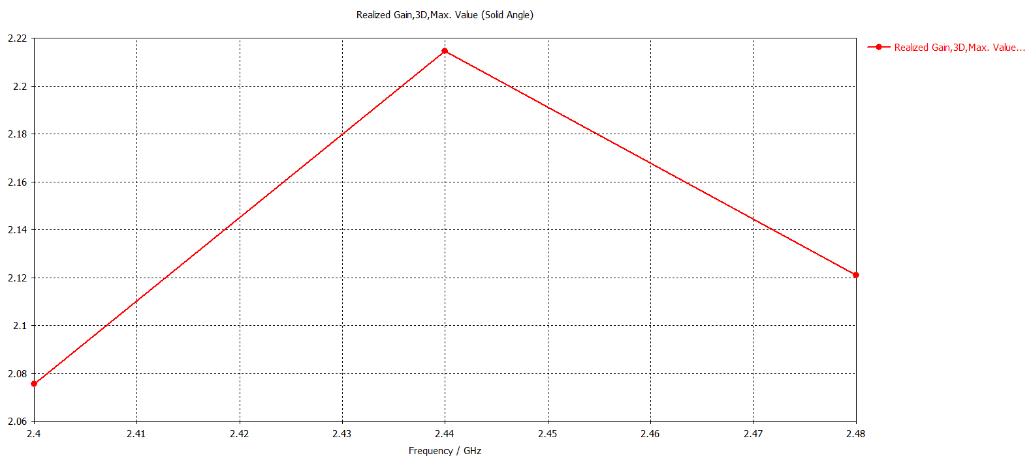

**Figure 5.4 Simulated antenna realized gain**

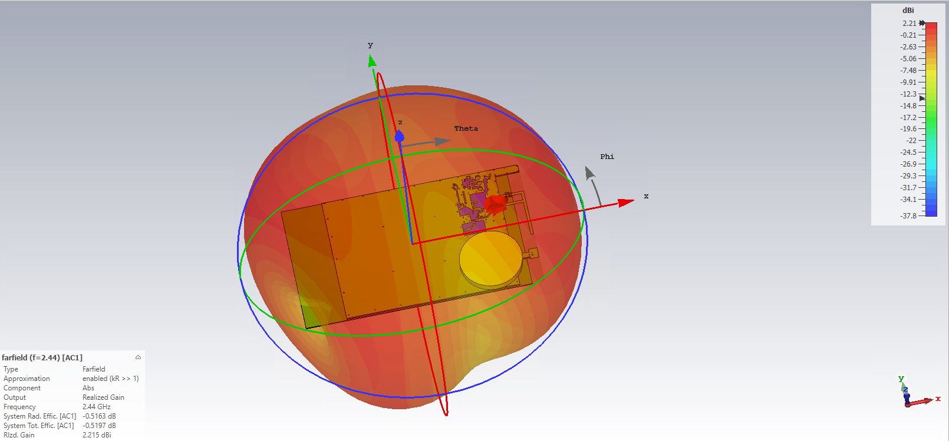

**Figure 5.5 Simulated antenna 3D far-field properties**

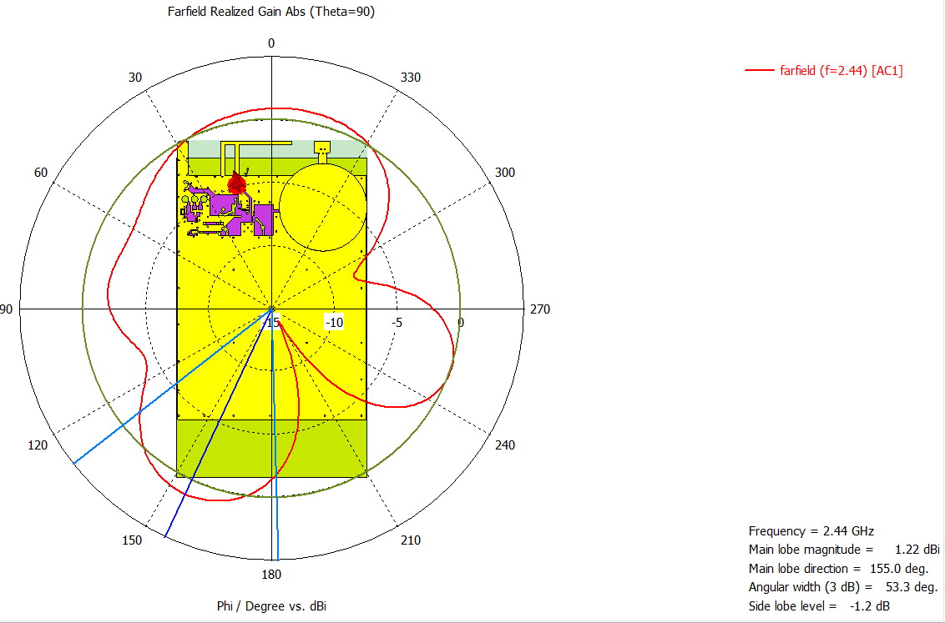

**Figure 5.6 Simulated antenna 1D far-field properties, Theta=90**

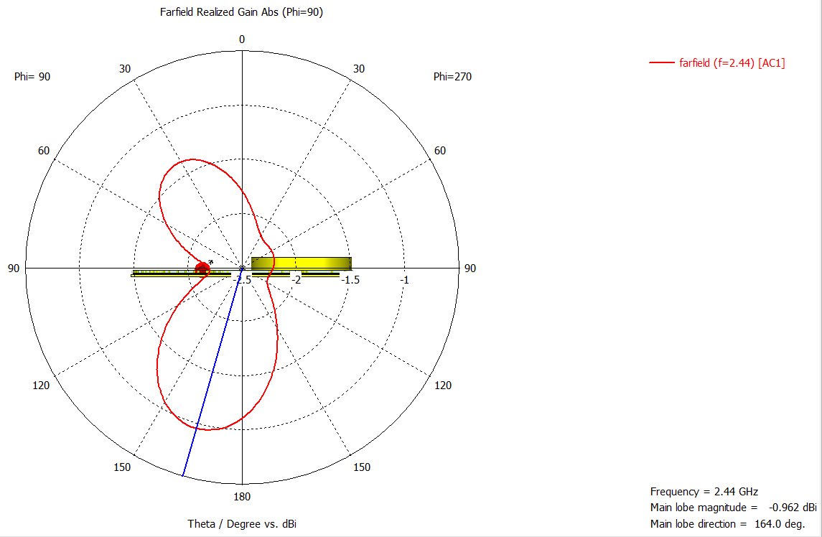

**Figure 5.7 Simulated antenna 1D far-field properties, Phi=90**

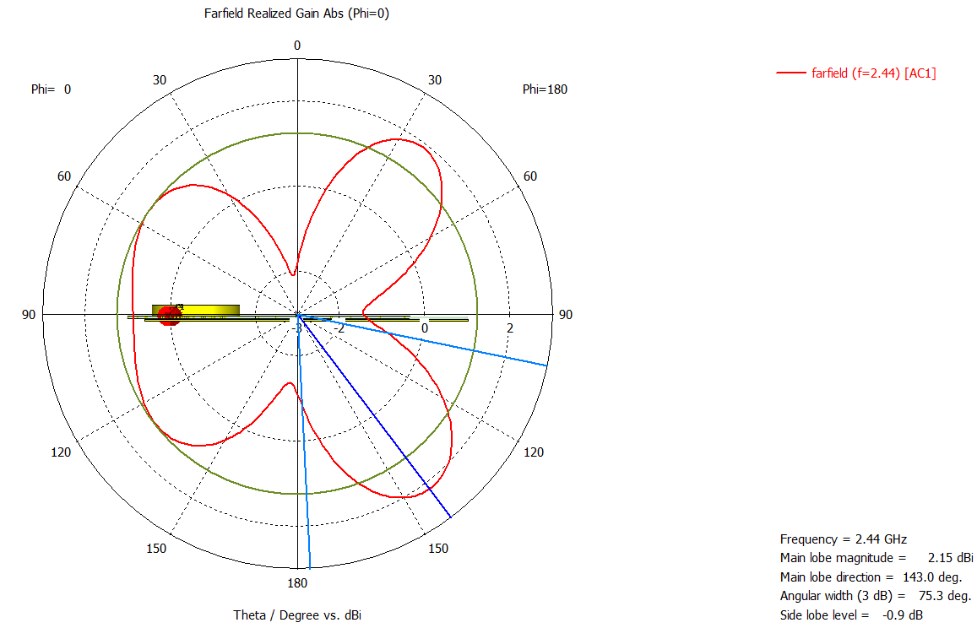

**Figure 5.8 Simulated antenna 1D far-field properties, Phi=0**

## Measurement Results

## Conducted TX Performance

The TX conducted performance results are demonstrated by the following SA plot in Figure 6.1.

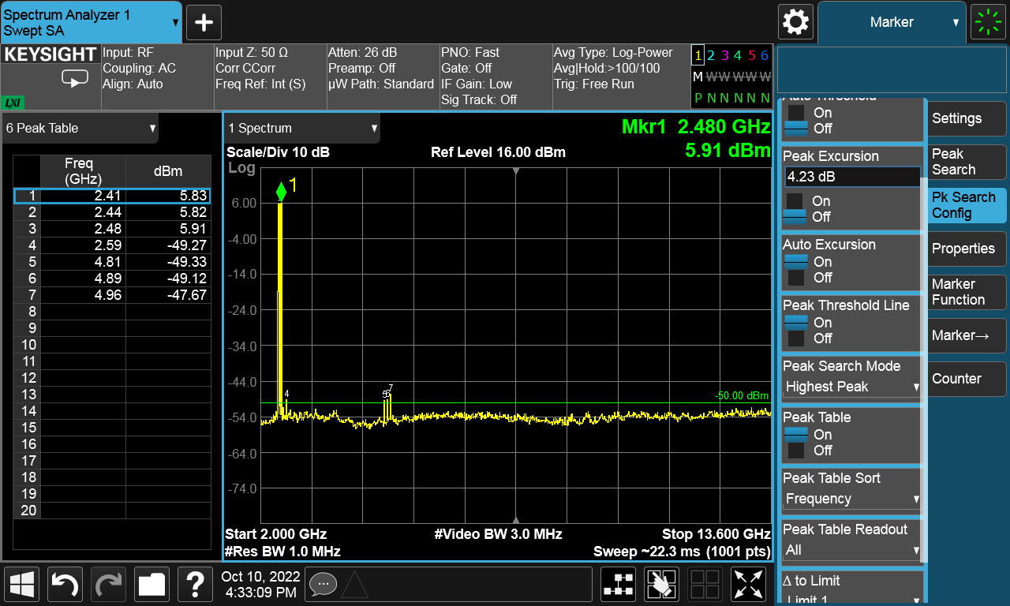

**Figure 6.1 Conducted Spectrum, power setting of +6 dBm**

## Conducted RX Performance

The conducted RX measurement results are demonstrated with the following charts. The receiver performance has been checked with Bluetooth LE 1 Mbps PHY (with 37-byte payload length), while the sensitivity limit is PER < 30.8%, which basically corresponds to BER < 0.1% for the same BLE 1 Mbps MSK signal.

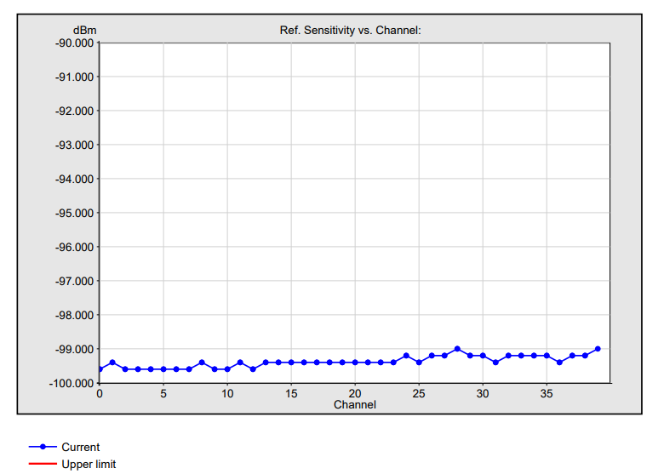

**Figure 6.2 Conducted Sensitivity vs. Frequency, BLE 1 Mbps, PER < 30.8%**

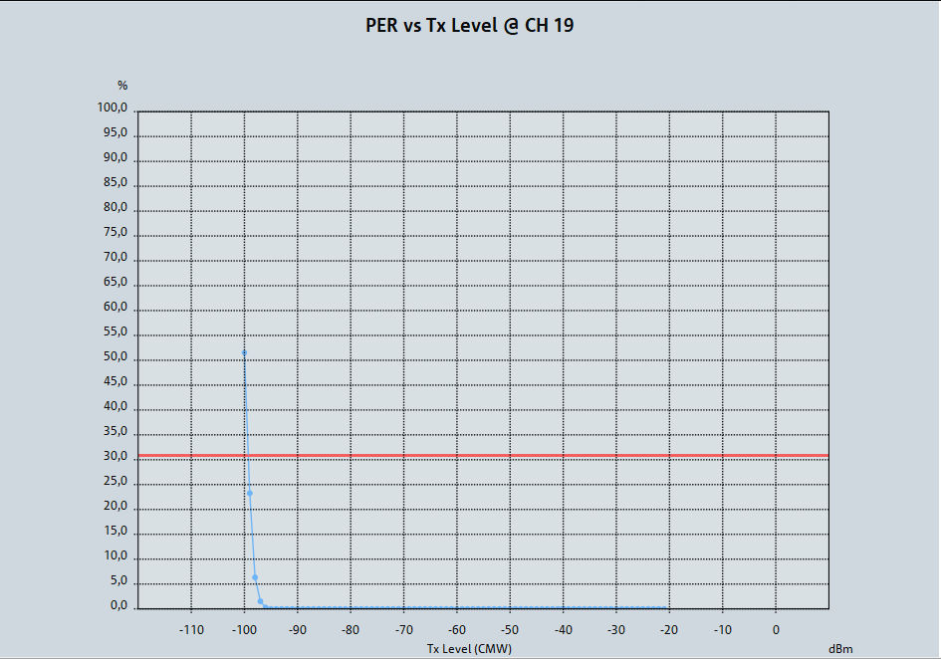

**Figure 6.3 Conducted PER waterfall curve, BLE 1 Mbps 37 byte, Channel 19**

## Antenna Impedance

The measured antenna impedance of the BLE ESL module’s printed antenna is shown in the figures below.

The antenna impedance tuning has been performed when the coin-cell battery was being inserted into, but without plastic enclosure. So, designs with plastic housing applied might need some further fine-tuning of antenna to achieve the best RF performance. Additionally, the antenna impedance has been checked when the EPD was overlapping with the BLE antenna and when it was not.

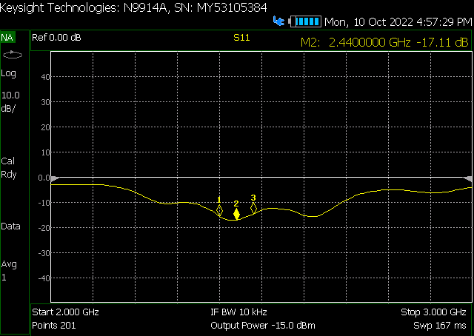

**Figure 6.4 Antenna Impedance, EPD in offset from the BLE antenna**

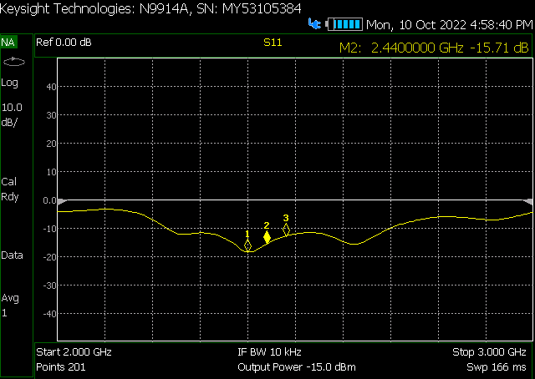

**Figure 6.5 Antenna Impedance, EPD overlapping the BLE antenna**

## Antenna Gain and Efficiency

The antenna gain and efficiency results of the on-board 2.4 GHz printed antenna of the BLE ESL module are summarized in the following charts.

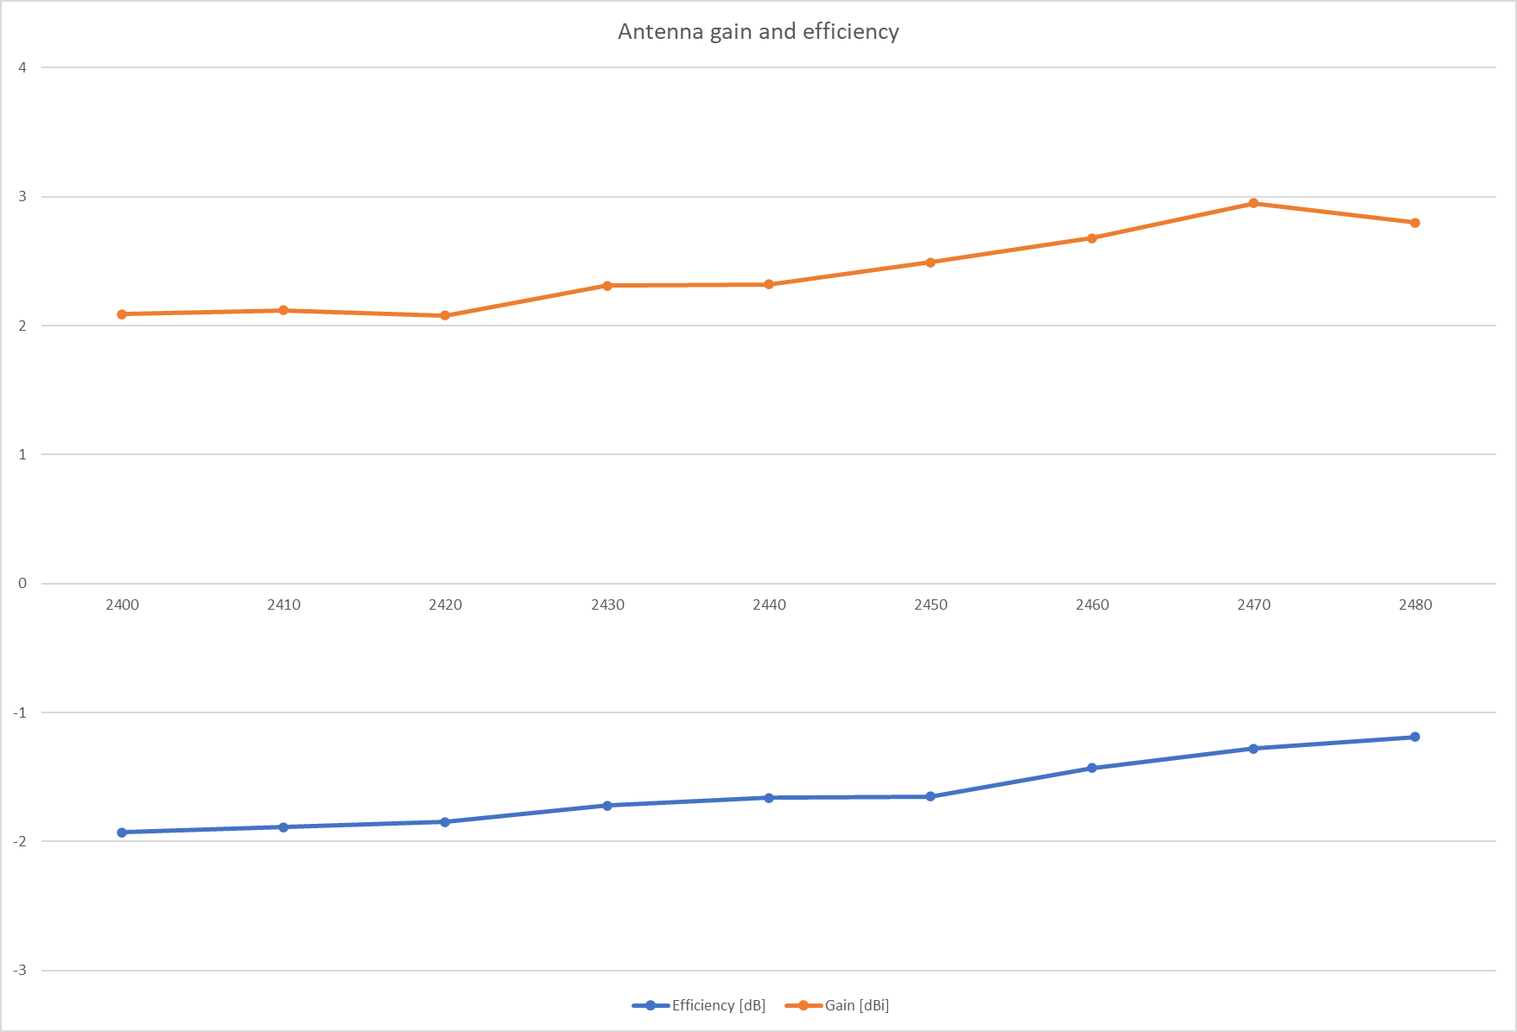

**Figure 6.6 Antenna gain and efficiency, EPD in offset from the BLE antenna**

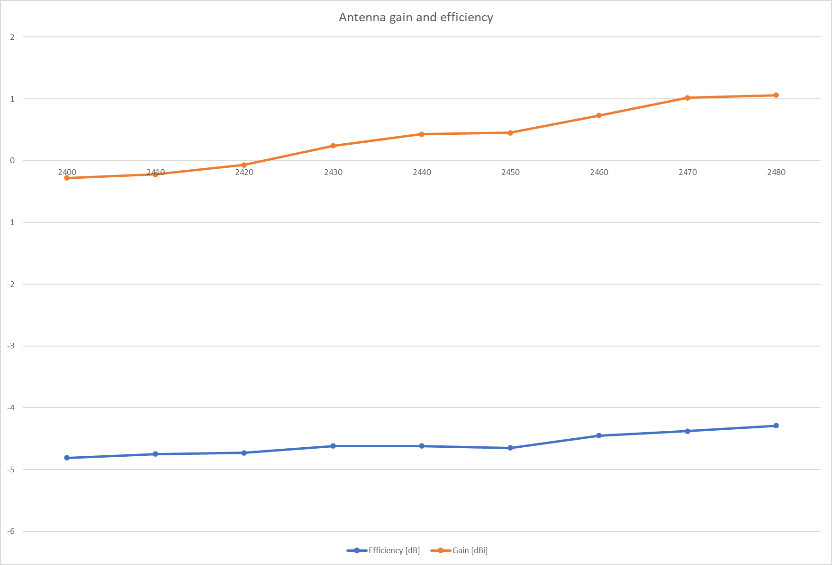

**Figure 6.7 Antenna gain and efficiency, EPD overlapping the BLE antenna**

## Radiation Patterns

The radiation patterns of the module have also been measured in an anechoic RF chamber, and the following plots represent the results.

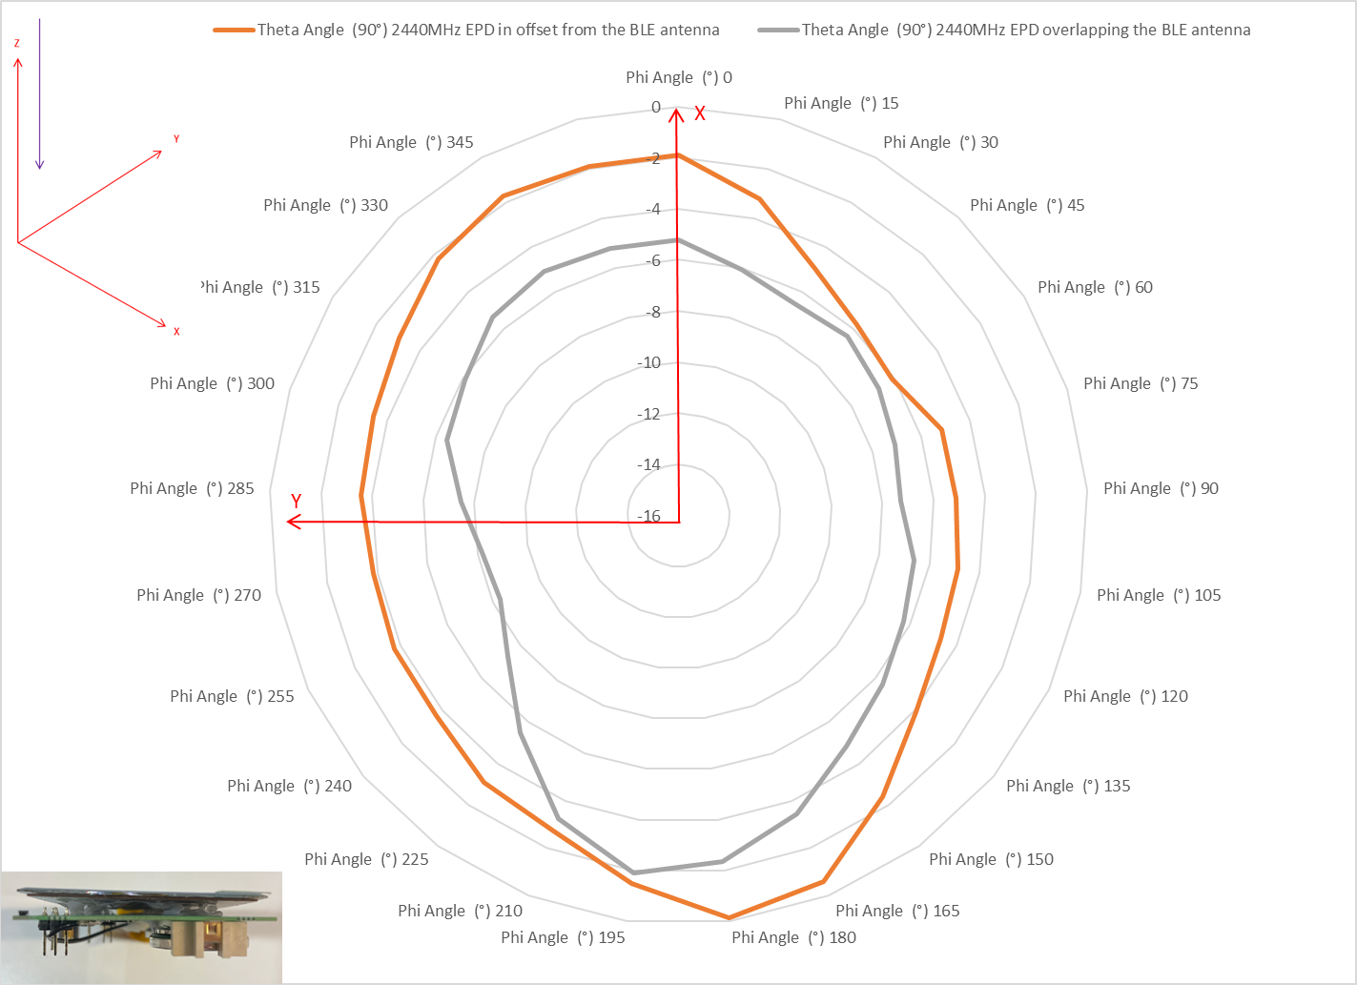

**Figure 6.8 Radiation pattern at Theta = 90**

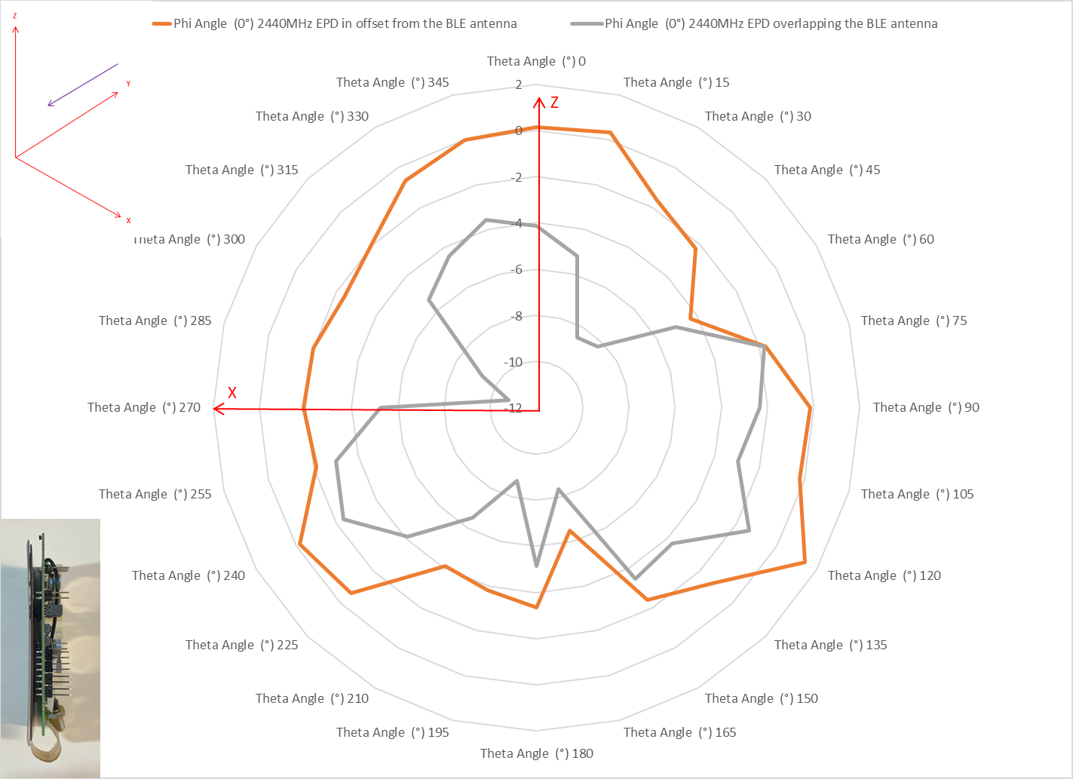

**Figure 6.9 Radiation pattern at Phi = 0**

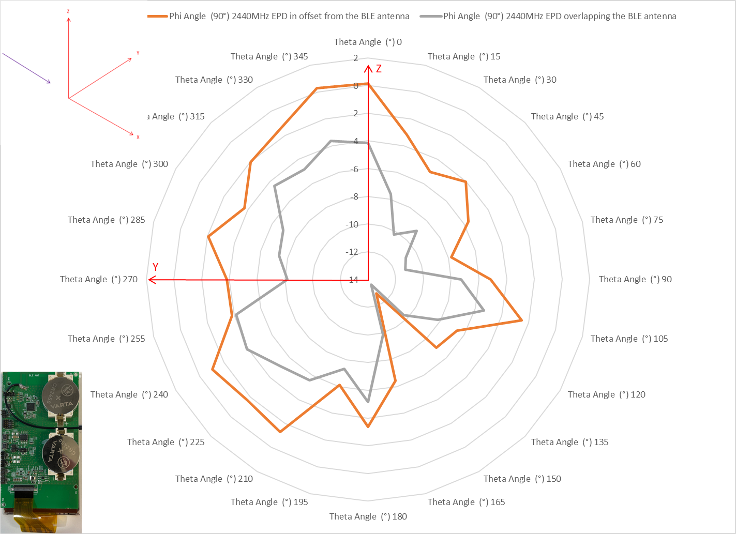

**Figure 6.10 Radiation pattern at Phi = 90**

## Radiated TRP, EIRP and Harmonics

The radiated fundamental TRP, EIRP and harmonics of the ESL module have also been measured in an anechoic RF chamber, and the following tables represent the results. The module has been measured in its stand-alone operation mode with a CW tone code running on it. The module was being supplied by the coin cell batteries.

The ESL reference design module complies with CE and FCC regulatory standards based on Silicon Labs’ pre-certification tests at the output power level setting of + 6 dBm, but the module does not have any official certification ID owned by Silicon Labs.

At the output power settings of +6 dBm the module complies with FCC and ETSI regulatory standards, using modulated signals the worst-case margin would be above 5 dB.

**Table 6.1 Fundamental TRP and EIRP results**

|  |  |  |  |  |  |
| --- | --- | --- | --- | --- | --- |
| **Channel** | **Conducted TXP** | **TRP** | **EIRP** | **Efficiency** | |
| **low** | 6.0 dBm | 3.1 dBm | 7.9 dBm | -2.9 dB | 50.8 % |
| **mid** | 6.0 dBm | 3.3 dBm | 8.2 dBm | -2.7 dB | 53.8% |
| **high** | 6.0 dBm | 3.5 dBm | 8.2 dBm | -2.5 dB | 55.7 % |

**Table 6.2 Radiated harmonic peak results**

|  |  |
| --- | --- |
| **Frequency** | **RMS Margin to Limit** |
| 16812.5 MHz | 17.71 dB |
| 16815.5 MHz | 17.35 dB |

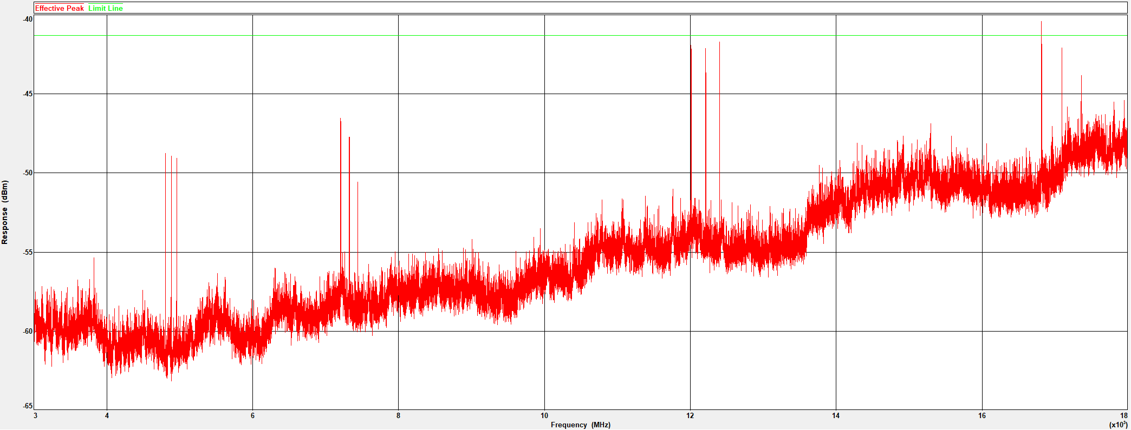

**Figure 6.11 Radiated harmonics at +6 dBm of output power settings**

**Smart. Connected. Energy-Friendly.**

**Products**



[*www.silabs.com/products*](http://www.silabs.com/products)

**Quality**

[*www.silabs.com/quality*](http://www.silabs.com/quality)

**Support and Community**

*community.silabs.com*

**Disclaimer**

Silicon Labs intends to provide customers with the latest, accurate, and in-depth documentation of all peripherals and modules available for system and software implementers using or intending to use the Silicon Labs products. Characterization data, available modules and peripherals, memory sizes and memory addresses refer to each specific device, and "Typical" parameters provided can and do vary in different applications. Application examples described herein are for illustrative purposes only. Silicon Labs reserves the right to make changes without further notice to the product information, specifications, and descriptions herein, and does not give warranties as to the accuracy or completeness of the included information. Without prior notification, Silicon Labs may update product firmware during the manufacturing process for security or reliability reasons. Such changes will not alter the specifications or the performance of the product. Silicon Labs shall have no liability for the consequences of use of the information supplied in this document. This document does not imply or expressly grant any license to design or fabricate any integrated circuits. The products are not designed or authorized to be used within any FDA Class III devices, applications for which FDA premarket approval is required, or Life Support Systems without the specific written consent of Silicon Labs. A "Life Support System" is any product or system intended to support or sustain life and/or health, which, if it fails, can be reasonably expected to result in significant personal injury or death. Silicon Labs products are not designed or authorized for military applications. Silicon Labs products shall under no circumstances be used in weapons of mass destruction including (but not limited to) nuclear, biological or chemical weapons, or missiles capable of delivering such weapons. Silicon Labs disclaims all express and implied warranties and shall not be responsible or liable for any injuries or damages related to use of a Silicon Labs product in such unauthorized applications.

**Trademark Information**

Silicon Laboratories Inc.®, Silicon Laboratories®, Silicon Labs®, SiLabs® and the Silicon Labs logo®, Bluegiga®, Bluegiga Logo®, ClockBuilder®, CMEMS®, DSPLL®, EFM®, EFM32®, EFR, Ember®, Energy Micro, Energy Micro logo and combinations thereof, "the world’s most energy friendly microcontrollers", Ember®, EZLink®, EZRadio®, EZRadioPRO®, Gecko®, Gecko OS, Gecko OS Studio, ISOmodem®, Precision32®, ProSLIC®, Simplicity Studio®, SiPHY®, Telegesis, the Telegesis Logo®, USBXpress® , Zentri, the Zentri logo and Zentri DMS, Z- Wave®, and others are trademarks or registered trademarks of Silicon Labs. ARM, CORTEX, Cortex-M3 and THUMB are trademarks or registered trademarks of ARM Holdings. Keil is a registered trademark of ARM Limited. Wi-Fi is a registered trademark of the Wi-Fi Alliance. All other products or brand names mentioned herein are trademarks of their respective holders.

**Silicon Laboratories Inc. 400 West Cesar Chavez Austin, TX 78701**



**USA**

[**http://www.silabs.com**](http://www.silabs.com/)